**程序代码**

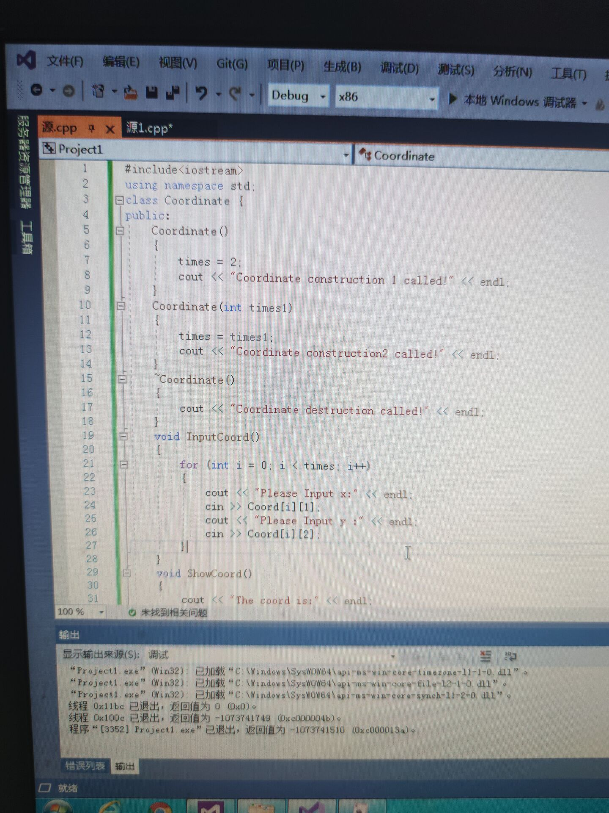

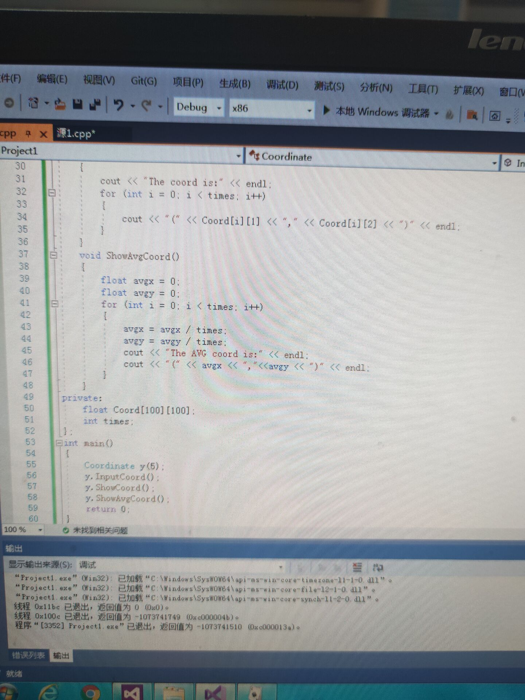

**程序结果**

Coordinate construction2 called!

Please Input x:

1

Please Input y:

1

Please Input x:

2

Please Input y:

2

Please Input x:

3

Please Input y:

3

Please Input x:

4

Please Input y:

4

Please Input x:

5

Please Input y:

5

The coord is:

(1,1)

(2,2)

(3,3)

(4,4)

(5,5)

The AVG coord is:

(3,3)

**程序代码**

#include<iostream>

#include<string>

using namespace std;

class Score {

public:

Score()

{

times = 2;

}

Score(int times1)

{

times = times1;

}

void InputNameAndScore()

{

for (int i = 0; i < times; i++)

{

cout << "请输入学生姓名：" << endl;

cin >> Name[i];

cout << "请输入科目A成绩：" << endl;

cin >> SScore[i][1];

cout << "请输入科目B成绩：" << endl;

cin >> SScore[i][2];

cout << "请输入科目C成绩：" << endl;

cin >> SScore[i][3];

}

}

void ShowNameAndScore()

{

for (int i = 0; i < times; i++)

{

cout << "姓名：" << Name[i] << "科目A成绩" << SScore[i][1] << "科目B成绩"

<< SScore[i][2] << "科目C成绩：" << SScore[i][3] << endl;

}

}

void ShowStdentAvgScore(int Sid)

{

float avg = 0;

avg = (SScore[Sid][1] + SScore[Sid][2] + SScore[Sid][3]) / 3;

cout << "姓名：" << Name[Sid] << "平均成绩：" << avg << endl;

}

void ShowClassAvgScore(string ClassName)

{

int Cid;

float avg = 0;

if (ClassName == "A")Cid = 1;

if (ClassName == "B")Cid = 2;

if (ClassName == "C")Cid = 3;

for (int i = 0; i < times; i++)

{

avg = avg + SScore[i][Cid];

}

avg = avg / times;

cout << "课程名称：" << ClassName << "平均成绩：" << avg << endl;

}

void OderScore(string ClassName)

{

int Cid;

if (ClassName == "A")Cid = 1;

if (ClassName == "B")Cid = 2;

if (ClassName == "C")Cid = 3;

for (int i = 0; i < times; i++)

{

SScore1[i] = SScore[i][Cid];

}

for (int i = 0; i < times; i++)

{

Name1[i] = Name[i];

}

for (int i = 1; i < times; i++)

{

if (SScore1[i] > SScore1[i - 1])

{

float temp = SScore1[i - 1];

SScore1[i - 1] = SScore1[i - 1];

SScore1[i] = temp;

string temp1;

temp1 = Name1[i - 1];

Name1[i - 1] = Name1[i];

Name1[i] = temp1;

}

}

cout << "课程名称：" << ClassName << endl;

for (int i = 0; i < times; i++)

{

cout << "姓名：" << Name1[i] << "成绩：" << SScore1[i] << endl;

}

}

private:

float SScore[100][3], SScore1[100];

string Name[100], Name1[100];

int times;

};

int main()

{

Score x;

x.InputNameAndScore();

x.ShowNameAndScore();

x.ShowStdentAvgScore(1);

x.ShowClassAvgScore("A");

x.OderScore("B");

return 0;

}

**运行结果**

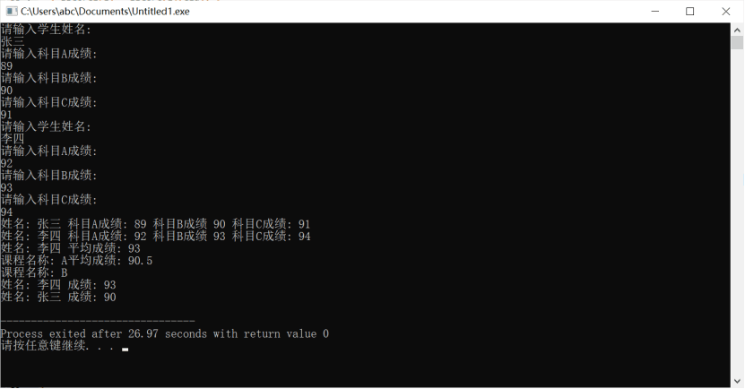

**感想心得**

这次上机实验深刻体会到了构造函数与析构函数的结构以及他们的运行顺序，对于析构函数、构造函数的内容有了更为深刻的理解，基本掌握了构造函数与析构函数的编写方法。